Satsang Centers Screen
  - Purpose
    - This screen manages the information of different satsang centers.
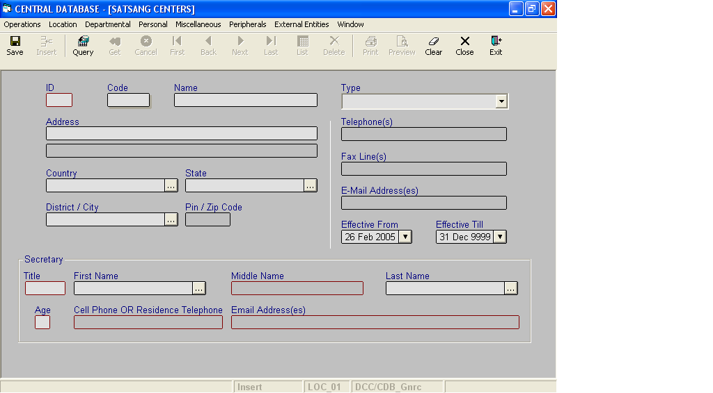

Layout as seen on opening of the Screen
  - Events associated
None
  - Modes
    - It will start in Insert mode.
    - It supports Insert, Query, Retrieve, Browse and List modes.
  - Field specifications
 | Type | Length | Optional | Insert Mode | Query Mode | BrowseMode
ID | satsang_centre_id | 4 | N | N.A. | Allow | Display
Code | char | 5 | N | Allow | Allow | Allow
Name | varchar | 25 | N | Allow | Allow | Allow
Type | Key |  | N | Allow | Allow | Allow
Address(Address Line 1) | address_line | 50 | N | Allow | Allow | Allow
Address(Address Line 2) | address_line | 50 | Y | Allow | Allow | Allow
Country | Key |  | N | Allow | Allow | Allow
State | Key |  | N | Allow | Allow | Allow
District/ City | Key |  | N | Allow | Allow | Allow
Pin / Zip Code | pin_or_zip_code | 6 | Y | Allow | Allow | Allow
Telephone(s) | telephone_lines | 50 | Y | Allow | Allow | Allow
Fax Line(s) | telephone_lines | 50 | Y | Allow | Allow | Allow
E- Mail Address(es) | email_addresses | 50 | Y | Allow | Allow | Allow
Effective From | datetime | 8 | N | Allow | Allow | Allow
Effective Till | datetime | 8 | N | Allow | Allow | Allow
Title | person_title | 10 | N | Display | Display | Display
First Name | Key |  | N | Allow | Allow | Allow
Middle Name | Person_part_nm | 30 | Y | Display | Display | Display
Last Name | Key |  | N | Allow | Allow | Allow
Age |  |  | N | Display | Display | Display
Cell Phone or Residence Phone | telephone_lines | 50 | Y | Display | Display | Display
Email Address(es) | email_address | 50 | Y | Display | Display | Display
  - Fields
    - ID
      - This is the ID of the satsang center, which uniquely identifies all the satsang centers.
      - This field will be automatically generated by the system.
      - The user will be informed of the generated ID as part of the message which will be shown on successful saving of information in Insert Mode.
    - Code
      - This is the code of the Satsang center.
      - It is user defined. It can be changed in Browse Mode.
      - Code of the satsang center is uniquely defined in the database.
    - Name
      - This is the name of the satsang center.
      - The name can be changed in Browse Mode.
      - Name of the satsang center is uniquely defined in the database.
    - Type
a) This is the type of the satsang center.
b) The type of the satsang center can be changed in Browse mode.
    - Address Line 1
a) This is the address of the satsang center.
b) This field is user defined. It can be changed in Browse Mode.
    - Address Line 2
a) This is the address of the satsang center.
b) This field is user defined. It can be changed in Browse Mode.
    - Country
a) This is the name of the country, where the satsang center is situated.
b) The country name can be changed in Browse Mode.
    - State
a) This is the name of the state, where the satsang center is situated.
b) The state name can be changed in Browse Mode.
    - District/City
a) This is the district or city, where the satsang center is situated.
b) The district/city can be changed in Browse Mode.
    - Pin/Zip Code
a) This is the pin or zip code of the place where the satsang center is situated.
b) The pin or zip code of the satsang center can be changed in Browse Mode.
    - Telephone(s)
a) This is the telephone number of the satsang center.
b) This field can be changed in Browse Mode.
    - Fax Line(s)
a) This is the Fax number of the satsang center.
b) This field can be changed in Browse Mode.
    - Email Address(es)
a) This is the e-mail Id of the satsang center.
b) This field can be changed in Browse Mode.
    - Effective From
      - This is the date since which satsang center is effective.
      - By default, the system will display the current date in Insert Mode.
      - Normally, it should not be a future date. This is the recommendation. System will display a warning, if future date is specified.
      - It cannot be later than the date specified in Effective Till.
    - Effective Till
      - This is the date till which a satsang center is effective.
      - By default, the system will display 31-Dec-9999 in Insert Mode.
      - Normally, it should not be a past date.
      - It cannot be earlier than the date specified in Effective From.

    - Title
a) This is the title of the Secretary of the satsang center.
b) This field is populated based on selection of the first name or last name of the secretary.

    - First Name
a) This is the first name of the Secretary of the satsang center.
b) This field can be changed in Browse Mode.

    - Middle Name
a) This is the middle name of the Secretary of the satsang center.
b) This field is populated based on selection of the first name or last name of the secretary.

    - Last Name
a) This is the last name of the Secretary of the satsang center.
b) This field can be changed in Browse Mode.
    - Age
a) This is the age of the Secretary of the satsang center.
b) This field is populated based on selection of the first name or last name of the secretary.
    - Cell Phone or Residence Phone
a) This is the mobile number or the residence phone number of the Secretary of the satsang center.
b) This field is populated based on selection of the first name or last name of the secretary.

    - Email Address(es)
a) This is the email ID of the Secretary of the satsang center.
b) This field is populated based on selection of the first name or last name of the secretary.
  - Lookup or Help
Field | Items of Information as will be shown | Remarks
Country | Name, Code | Only active countries will be shown.
State | Name, Code | Only active states will be shown.
District or City | Name, Code | Only active districts or cities will be shown.
First Name(in Secretary Frame) | First Name, Middle Name, Last Name | Only active secretary’s names will be listed.
Last Name(in Secretary Frame) | Last Name, First Name, Middle Name | Only active secretary’s names will be listed.

  - Action Buttons
None
  - Users / User Roles
CDB_Gnrc user is permitted to insert, update, delete and select satsang center.
  - Other Considerations
None

